

**TOPIC: Medical Inventory ManagementNM_ID:5994EA17784DD6F91F845E9042796D27**

**TEAMDETAILS:**

➔**TeamLead:ELAYARANI N**

**---E-mail:23bsct215elayaranin@skacas.ac.in**

**---Reg-no:2326k0305**

➔**Teammember1:INDHUMATHI R**

**---E-mail:**[**23bsct219indhumathir@skacas.ac.in**](mailto:23bsct219indhumathir@skacas.ac.in)

**---Reg-no:2326k0309**

➔**Teammember2:JANIKAA J A**

**---E-mail:**[**23bsct221janikaaja@skacas.ac.in**](mailto:23bsct221janikaaja@skacas.ac.in)

**---Reg-no:2326k0311**

➔**Teammember3:JEEVA G**

**---E-mail:**[**23bsct222jeevag@skacas.ac.in**](mailto:23bsct222jeevag@skacas.ac.in)

**---Reg-no:2326k0312**

# ProjectOverview

**MedicalInventoryManagement**isaSalesforce-basedsolutiondesignedtostreamlinethe tracking, storage, and distribution of medical supplies. The system provides **real-time visibility of stock**, **automated alerts for low or expiring items**, and **seamless supplier integration** to ensure uninterrupted availability of critical resources.

ByleveragingSalesforcedashboards,forecastingtools,androle-basedaccess,thesolution helps healthcare providers **reduce waste, minimize shortages, cut costs, and improve patient care**. Beyond efficiency, the project ensures **compliance, transparency, and sustainability**, creating a reliable model for modern healthcare systems.

# Objectives

* + Ensure**accuratetracking**ofmedicalsupplies,consumablesand equipment.
  + Provide**real-timeinventoryvisibility**acrossmultiplelocations.
  + Automate**stockreplenishment andalerts**forloworexpiringitems.
  + Maintain**complianceandauditreadiness**throughaccuraterecords.
  + Improve**efficiencyinprocurementanddistribution**ofmedicalitems.

# BusinessGoals:

* + **Ensure Resource Availability**: Maintain optimal stock levels of medicines, equipment,andconsumablestopreventshortagesanddelaysinpatientcare.
  + **MinimizeWaste:**Trackusageandexpirationdatestoreduceoverstockingand wastage of critical medical supplies.
  + **OptimizeOperations**:Automateinventorymanagement,procurement,and reporting to streamline processes and reduce manual errors.
  + **Enhance Compliance and Accountability:** Provide transparent tracking, audit- readyreports,andsecurerole-basedaccesstoensureregulatoryadherenceand trust.

# SpecificOutcomes:

## →CentralizedInventoryControl:

* + Maintainaunifiedplatformtotrackmedicines,consumables,andequipmentacross locations.
  + Providereal-timevisibilityintostocklevels,usage,andexpirationdates.
  + Generatecompliance-readyreportsforauditsandregulatoryneeds**.**

## →SmartAutomation:

* + Triggerautomaticpurchaserequestswhenstockreachesminimumthresholds.
  + Sendproactivealertsforupcomingexpirationstominimize wastage.
  + Optimizesupplydistributiontoensuretimelyavailabilityincriticalareas,

## →SeamlessCollaboration:

* + Strengthencoordinationbetweenhealthcarestaff,suppliers,andadministrators.
  + Facilitatefasterapprovalworkflowsforprocurementandrestocking.
  + Providesecure,role-basedaccesstoensure accountability.

# SalesforceKeyFeaturesandConceptsUtilized:

**Medical Inventory Management** leverages the capabilities of Salesforce to build a reliable, transparent,andefficientplatformformanaginghealthcaresupplies.Here’showSalesforce features have been applied:

# CreationofSalesforceAccount(DeveloperEdition):

LogginginthroughSalesforceDeveloperEditionprovidedasecureandfreeenvironment to design, test, and implement project components without affecting real data. It enabled hands-onpracticewithobjects,apps,reports,anddashboards,offeringarisk-freeplatform to build and demonstrate the Medical Inventory project effectively.

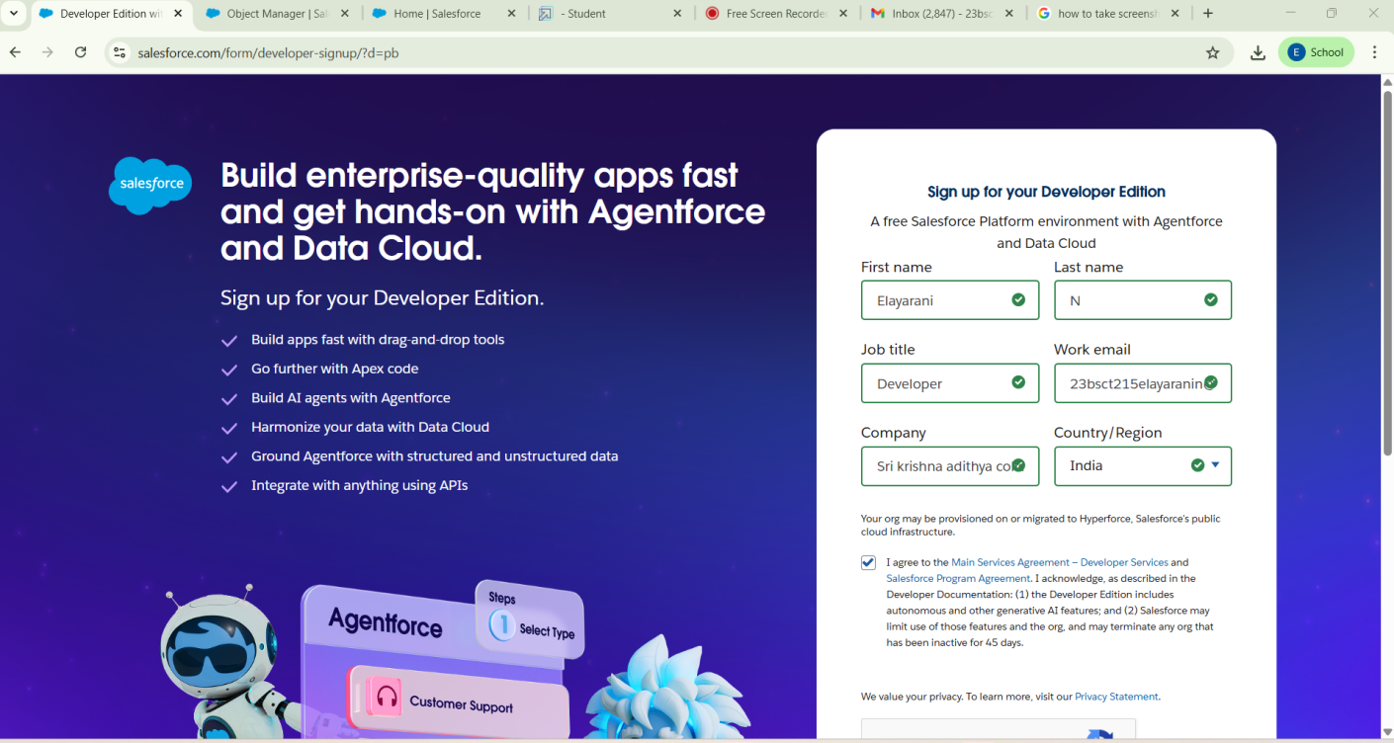

# CreationofObjects:

Objects act as structured containers for storing and organizing data related to specific businessprocesses.Creatingcustomobjectsallowsthesystemtomanageallaspectsof medical inventory efficiently and systematically.

***CustomObjects:Product,Purchaseorder,Supplier,OrderitemandInventoryTransactions are created.***

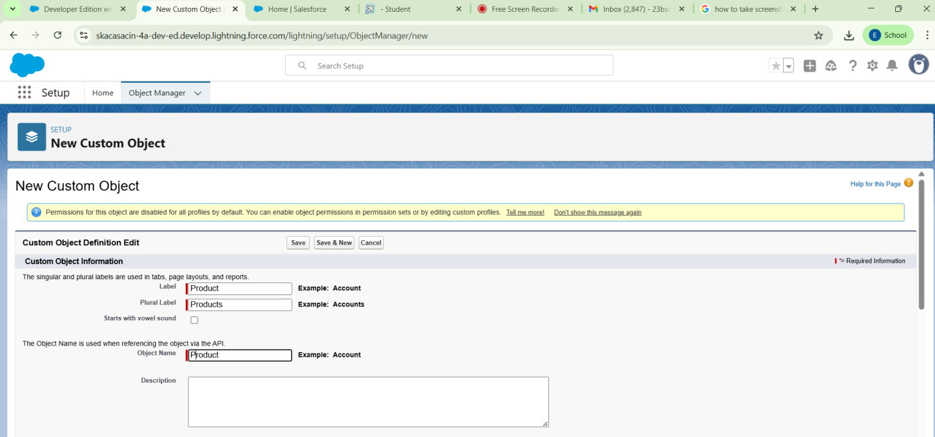

# Creationof Tabs:

Tabs serve as the primary navigation elements that allow users to access and manage differentobjectswithintheapplicationcreating,thesecustomtabsensuresthatkeyrecords are easily accessible, organized, and user-friendly.

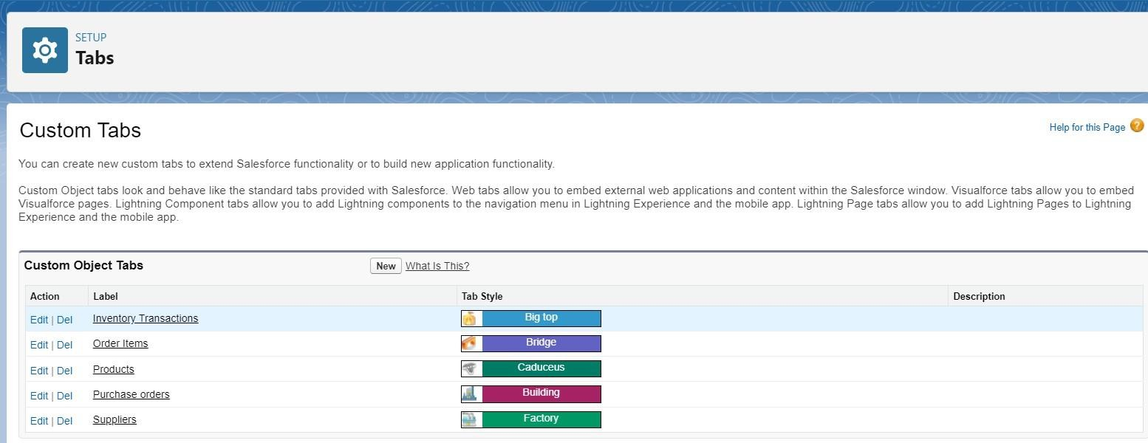

# CreationofAppManager:

TheAppManagerisusedtodesignandorganizecustomapplicationsthatbringtogetherall therequiredtabs,objects,andtoolsinoneplacebycreatingacustomappthroughtheApp Manager ensures that users can work in a focused, role-specific environment tailored to healthcare operations.

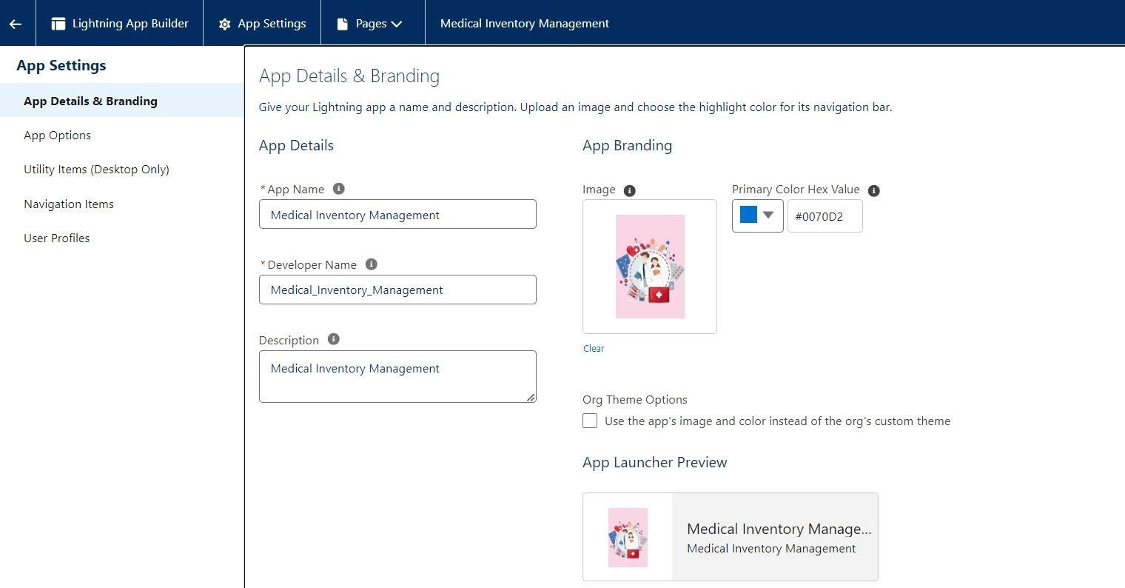

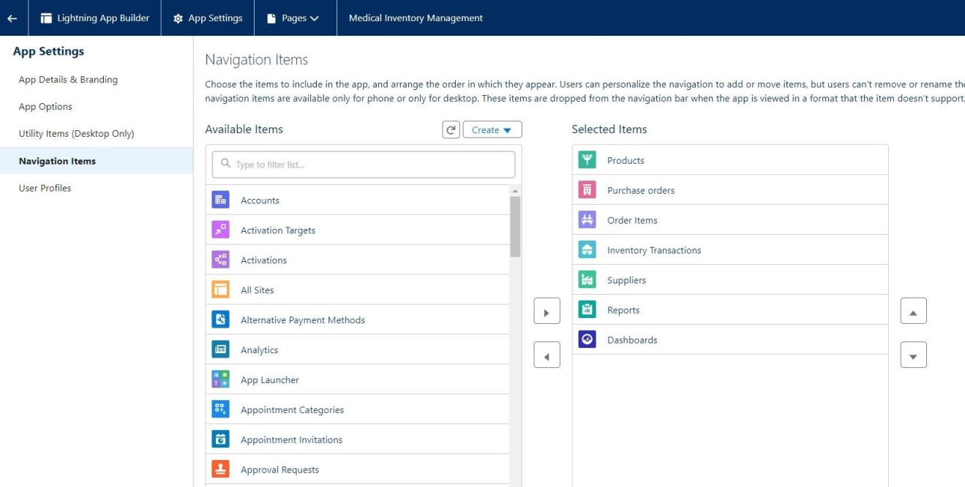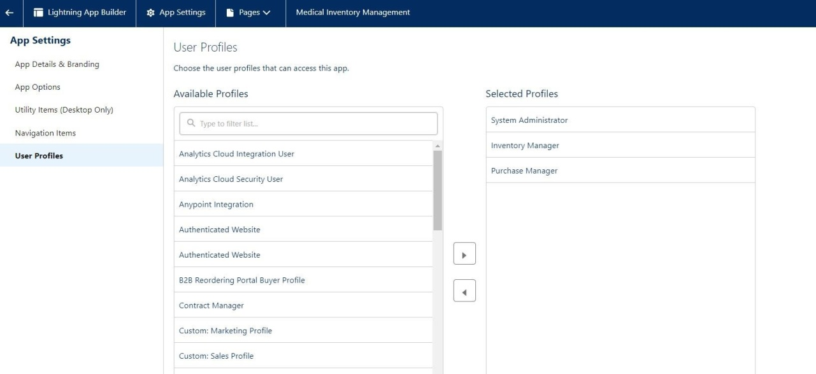

# CreationofFields:

## →InventoryRecords:

* + **Products:**

Storedetailedinformationaboutmedicines,consumables,andequipment,including batch numbers, stock levels, expiry dates, and product descriptions, product ID and product names.

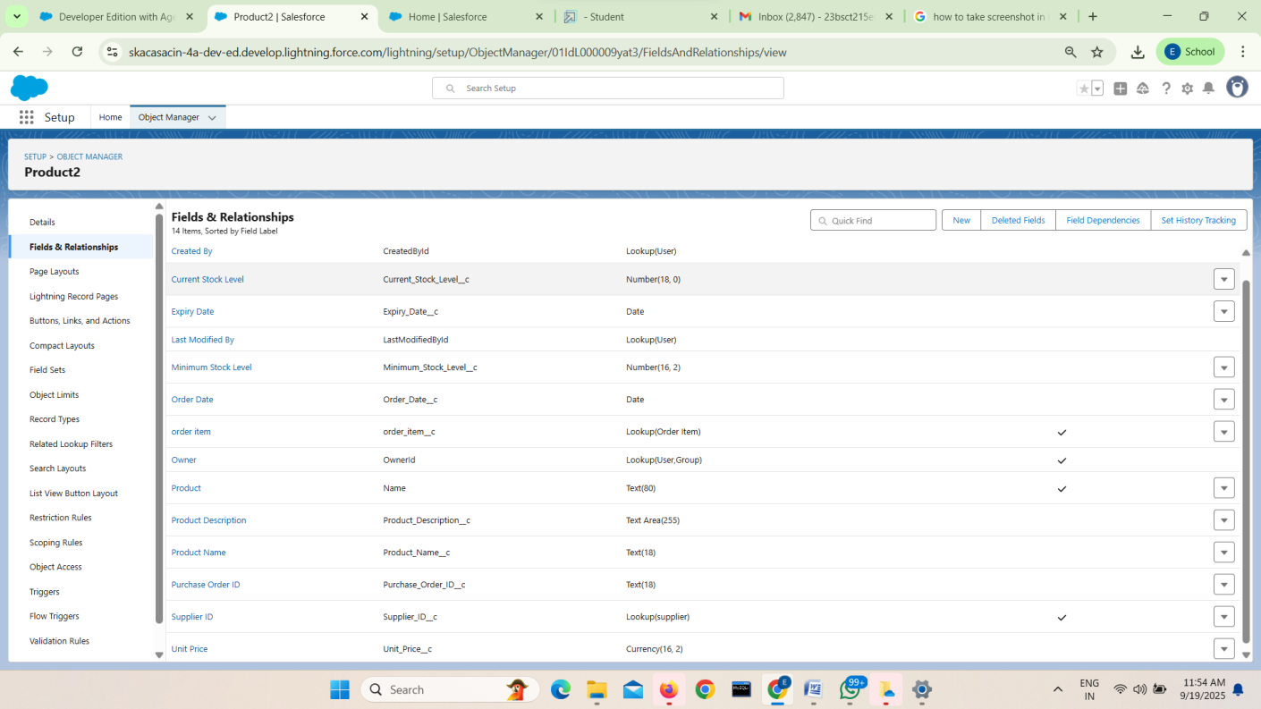

## PurchaseOrders:

Recordandmanagesupplierorderswithdetailssuchasitemsrequested,ordercount, order dates, purchase order ID and supplier ID, making it easier for staff to track procurement and ensure timely restocking.

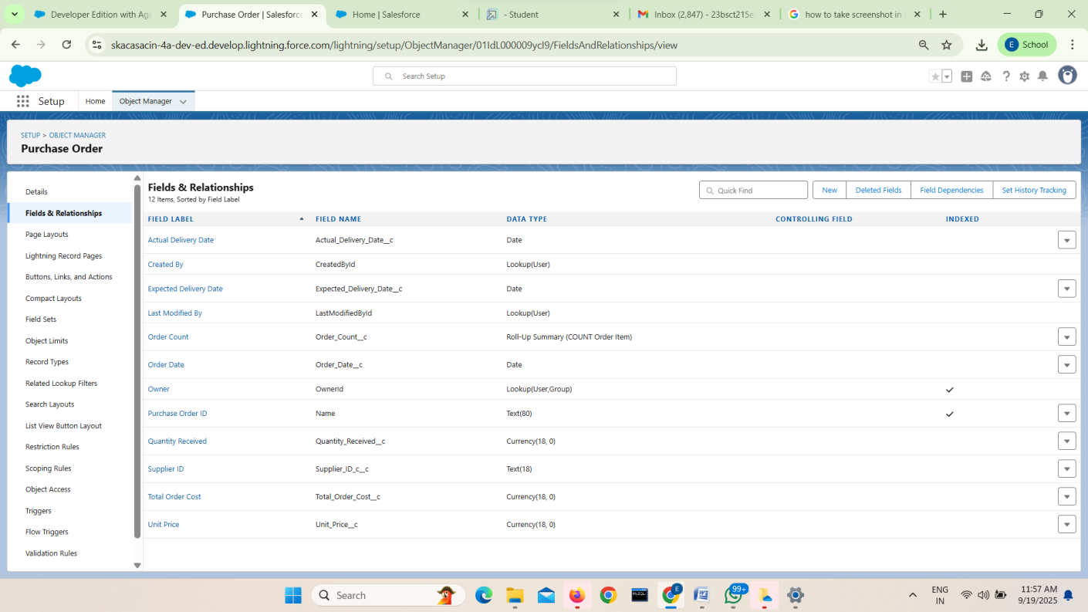

## OrderItems:

Trackandmanageindividualitemswithineachpurchaseorder,withfieldsforproduct name, quantity ordered, quantity received, unit price, and total order cost ensuring clarity and accuracy in procurement records.

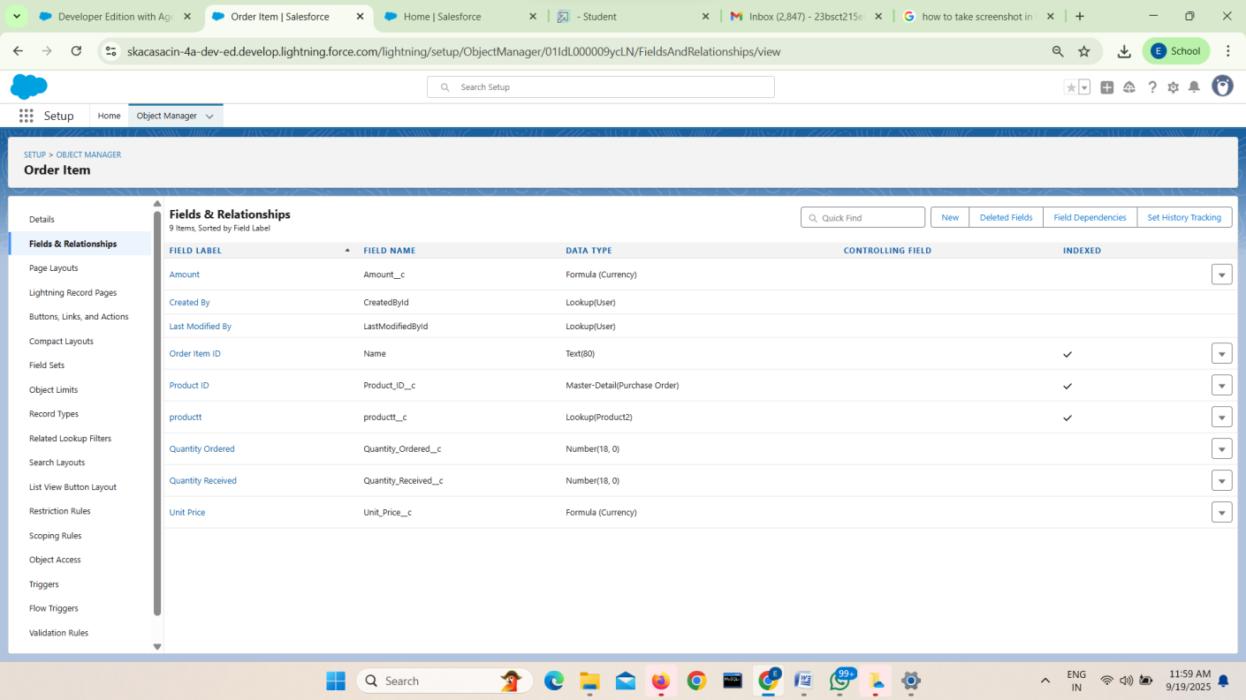

## InventoryTransactions:

Maintain a centralized log of all stock movements, including details of items issued, received,returned,oradjusted,alongwithinventorytransactionID,Purchaseorderid, Transaction dates and Transaction types and Total order cost ensuring complete transparency and traceability of inventory activities.

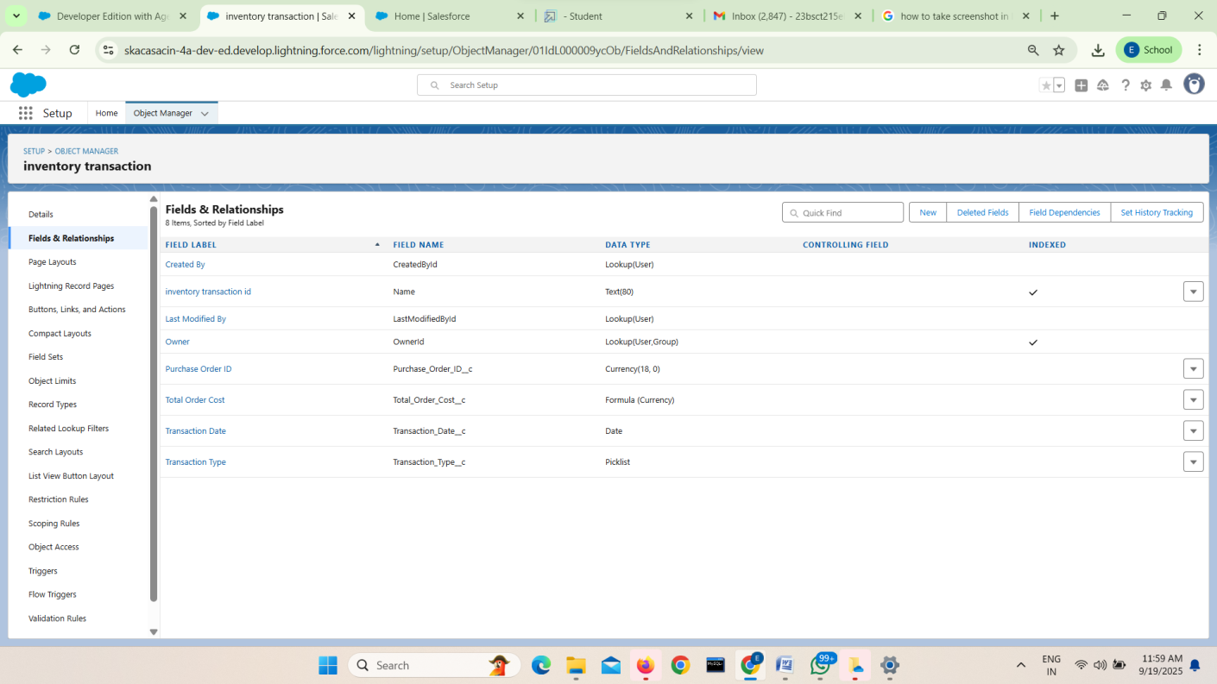

## Supplier:

Storeandmanagedetailedinformationaboutsuppliers,includingcontactperson,phone number, supplier ID and supplier name, enabling efficient procurement and strong vendor relationships.

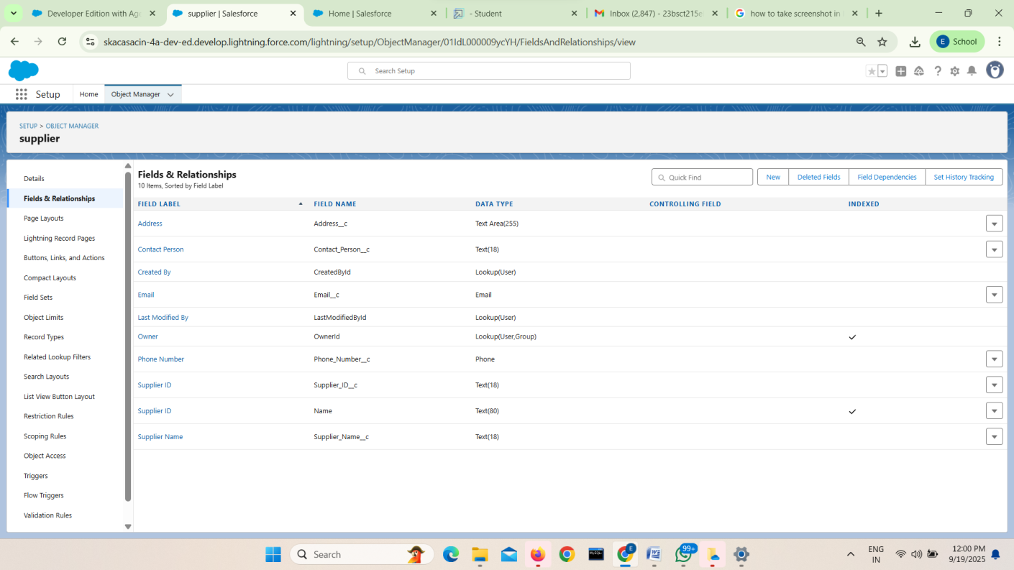

## →Relationships:

* + **Master–DetailRelationships:**

Createstructuredconnections,suchaslinking*purchaseorders*totheir*orderitems*, ensuring data consistency and clear hierarchy in inventory records.

* + **LookupRelationships:**

Enableflexibleassociations,likeconnecting*inventorytransactions*to*suppliers*or

*storagelocations*,allowingdynamictrackingandmanagementofstockmovements.

# Editingofpagelayouts:

## ➔Editapagelayoutinproductobject:

Editing theProduct pagelayout ensures relevant fields areorganized for easy dataentry and viewing.Itimprovesaccuracyandefficiencybyshowingonlynecessaryinformationbasedon user roles.

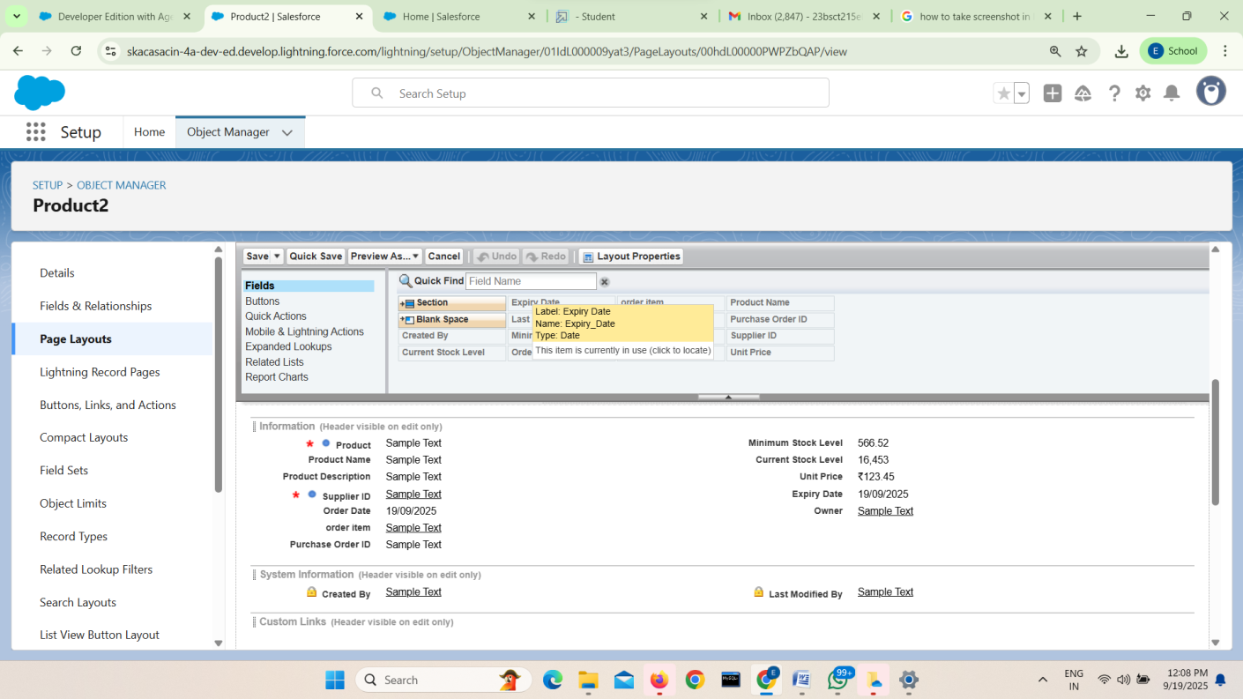

## ➔Editapagelayoutinpurchaseorderobject:

Editing the Purchase Order page layout ensures clear organization of vendor, product, and delivery details for efficient data entry. It helps users focus on relevant fields based on their roles, reducing errors. This improves order tracking, compliance, and overall workflow in the procurement process.

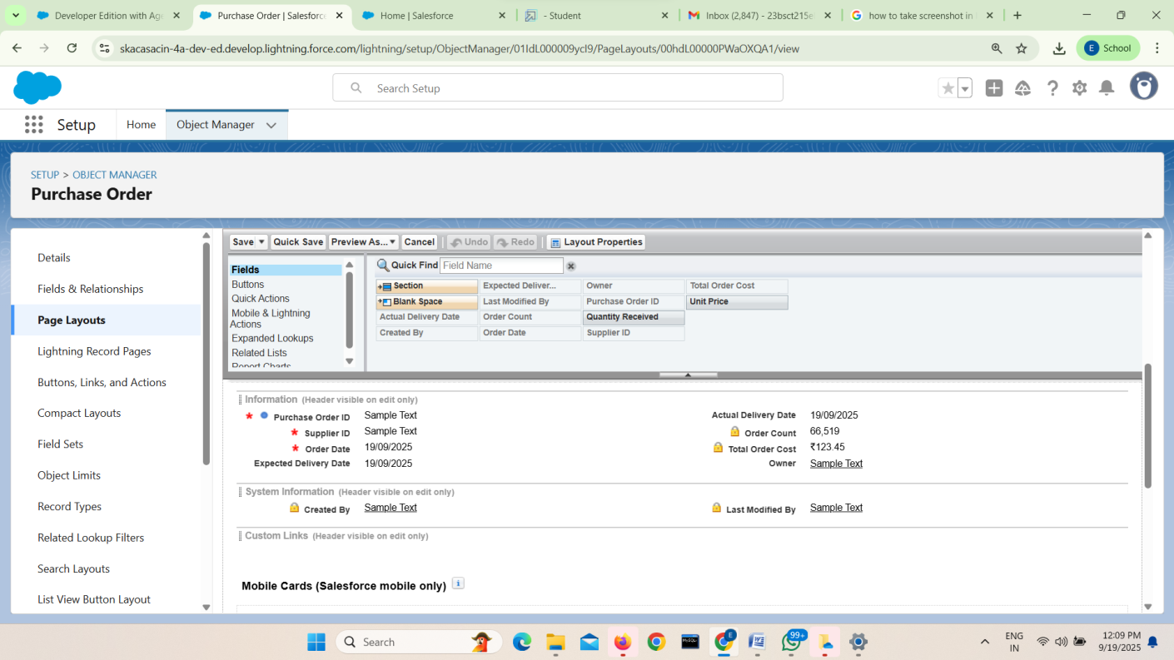

## ➔Editapagelayoutinorderitemobject:

EditingtheOrderItempage layouthelpsdisplaykeydetailslikeproductname,quantity,and price in a clear and organized manner. It ensures accurate data entry and simplifies tracking of individual items within a purchase order. This enhances inventory accuracy and supports efficient order processing.

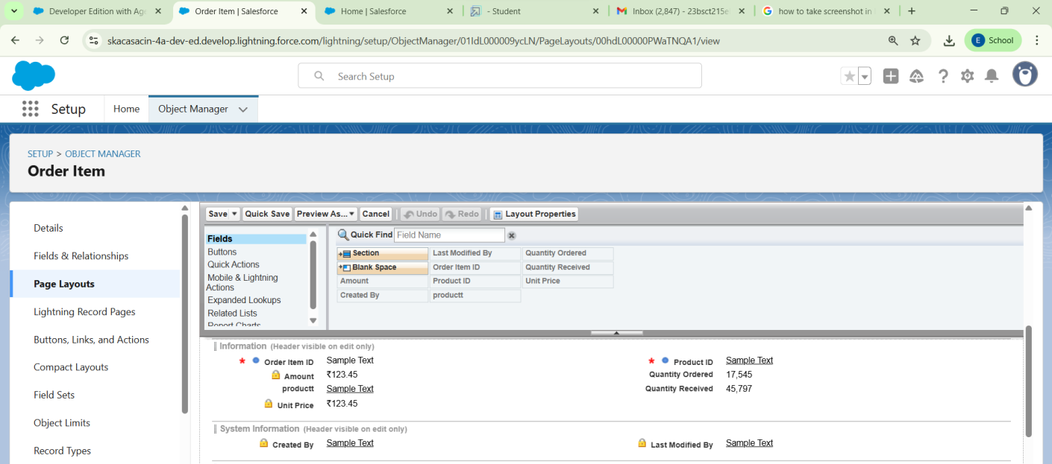

## ➔Editapagelayoutininventorytransactionobject:

EditingtheInventoryTransactionpagelayoutensuresclearvisibilityoftransactiondetailslike product, quantity, date, and transaction type. It helps users record and track stock movements accurately. This supports effective inventory control and audit readiness in the medical inventory system.

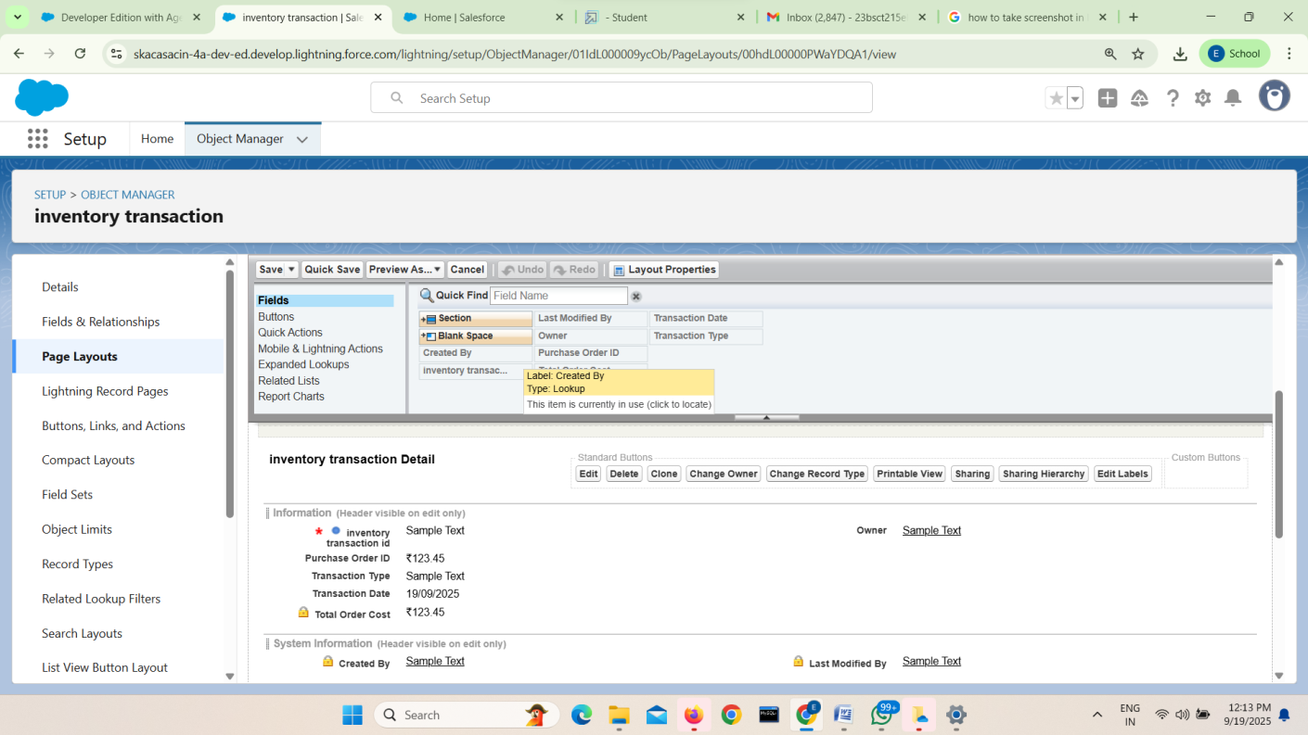

## ➔Editapagelayoutinsupplierobject:

EditingtheSupplierpagelayoutallowsforclearorganizationofkeysupplierdetailslikename, contact info, and product categories. It ensures users can quickly access and update supplier records accurately. This supports efficient procurement processes and maintains reliable supplier data.

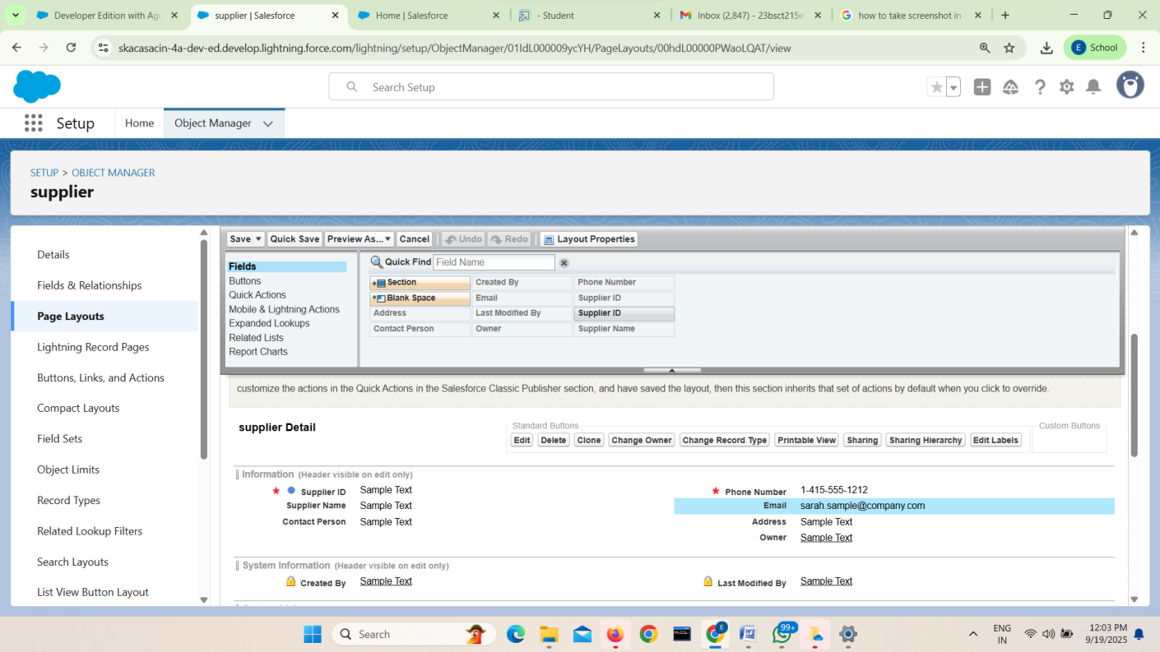

# Compactlayouts:

## ➔Createacompactlayouttoaproductobject:

Creatingacompact layoutfortheProduct objectensuresthatessentialproductdetails (like name,code,andstockstatus)arevisibleataglance.Itimprovesuserefficiencybyshowing keyinfoinlistviews,lookups,andmobileviews.Thissupportsfasterdecision-makingand streamlined inventory management.

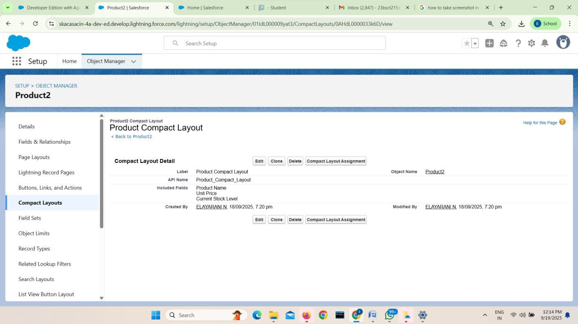

## ➔Createacompactlayouttoapurchaseorderobject:

Creating a compact layout for the Purchase Order object allows key information like order number,vendor,andstatustobeeasilyseeninlistviewsandsearchresults. Itimprovesquick access and selection of records for users. This boosts efficiency in managing and tracking purchase orders within the medical inventory system.

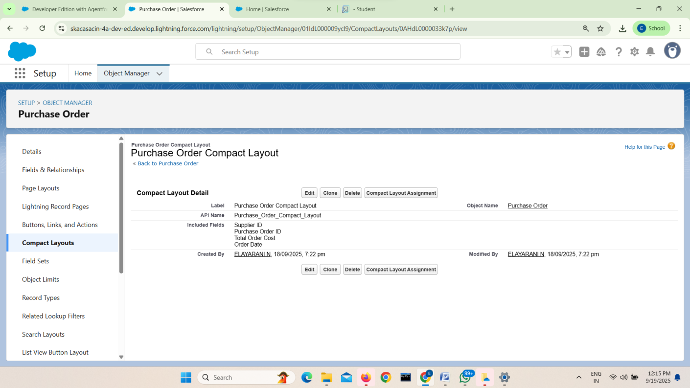

# Validationrules:

## ➔Createanexpecteddeliverydatevalidationruletoaemployeeobject:

CreatinganexpecteddeliverydatevalidationruleontheEmployeeobjectensuresthatdelivery dates entered are realistic and not set in the past. It helps maintain accurate scheduling and inventory planning. This improves reliability and prevents errors in the medical inventory management process.

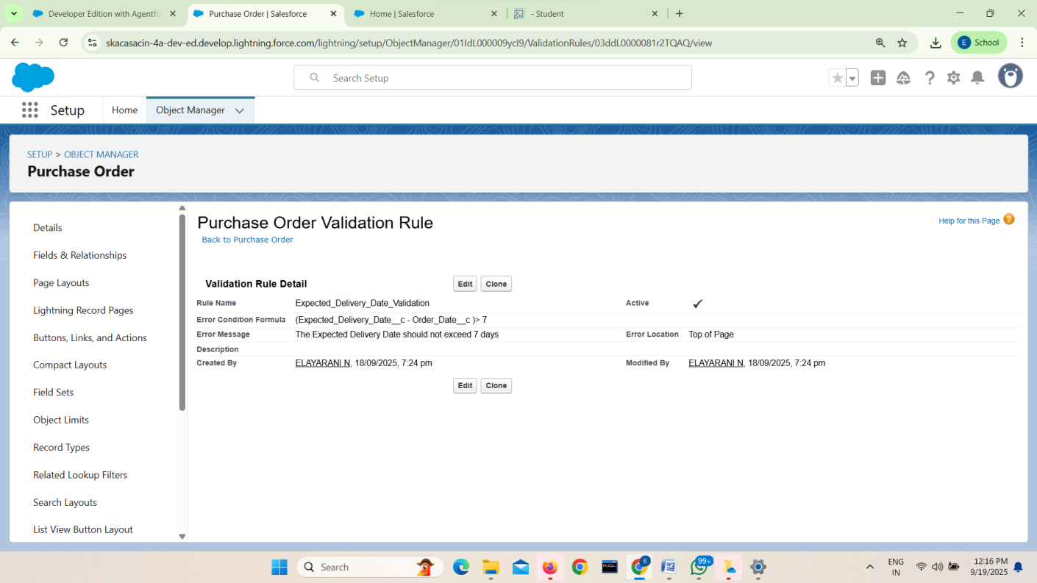

# DataSharingandSecurity:

## ➔ProfilesandRoles:

Define both inventory manager and purchasing manager roles with specific access permissions,ensuringthatadministrators,hencestaffcancollaborateeffectivelywhile protecting sensitive medical and supplier data.

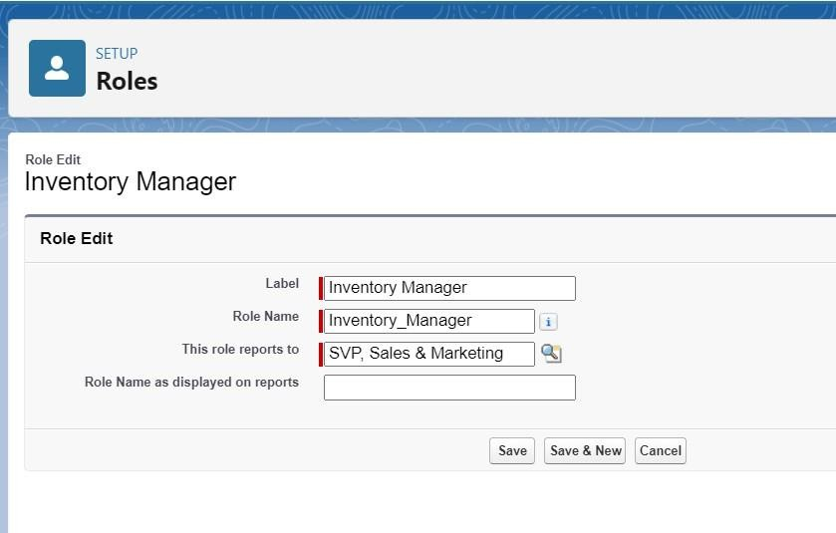

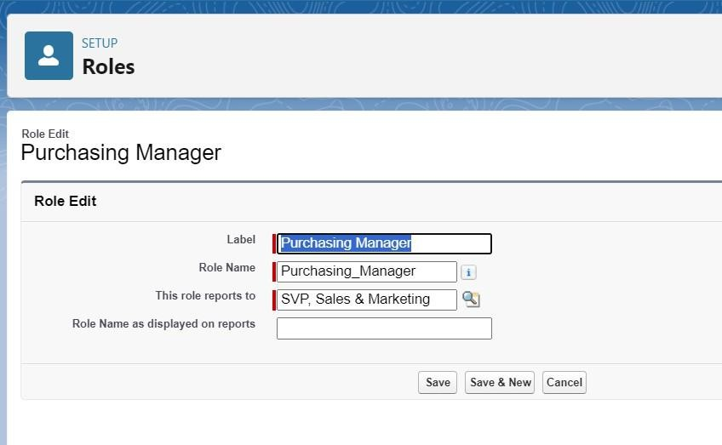

## Users:

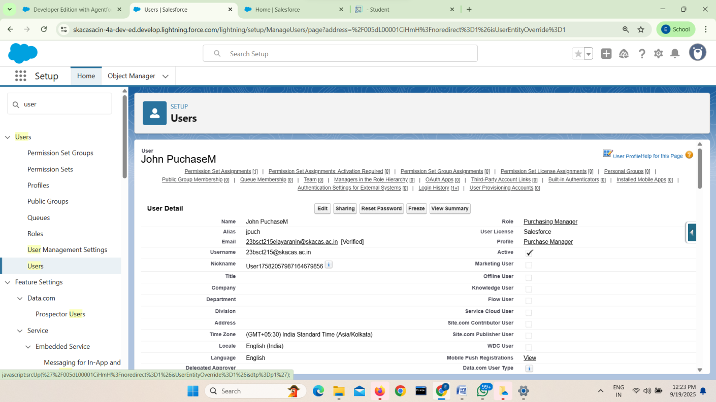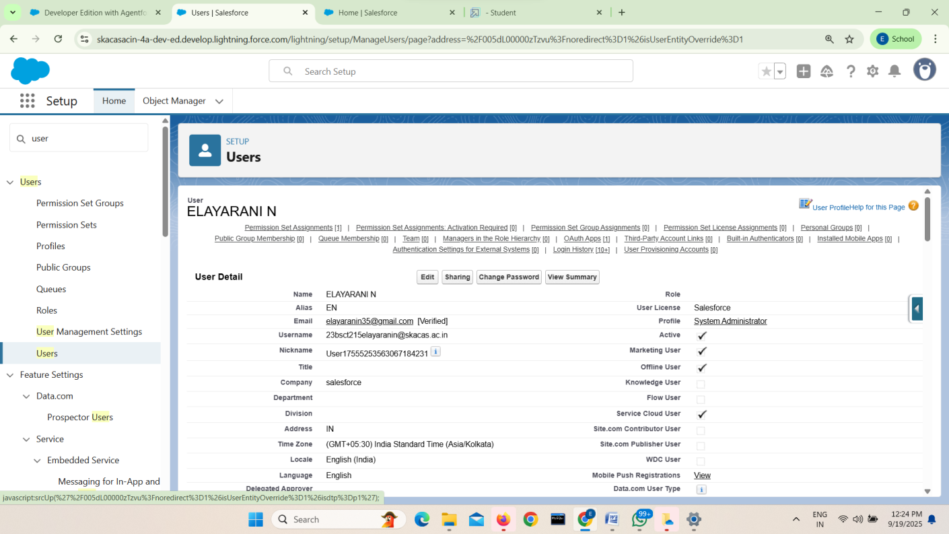

➔**CreationofPermissionsets:**

PermissionSetsareusedtoextendaccessbeyondwhatisdefinedinuserprofiles,without changing the core profile settings. Permission Sets (Purchase Manager Create Access) ensure that specific users can access additional features or objects as needed, while still maintaining data security.

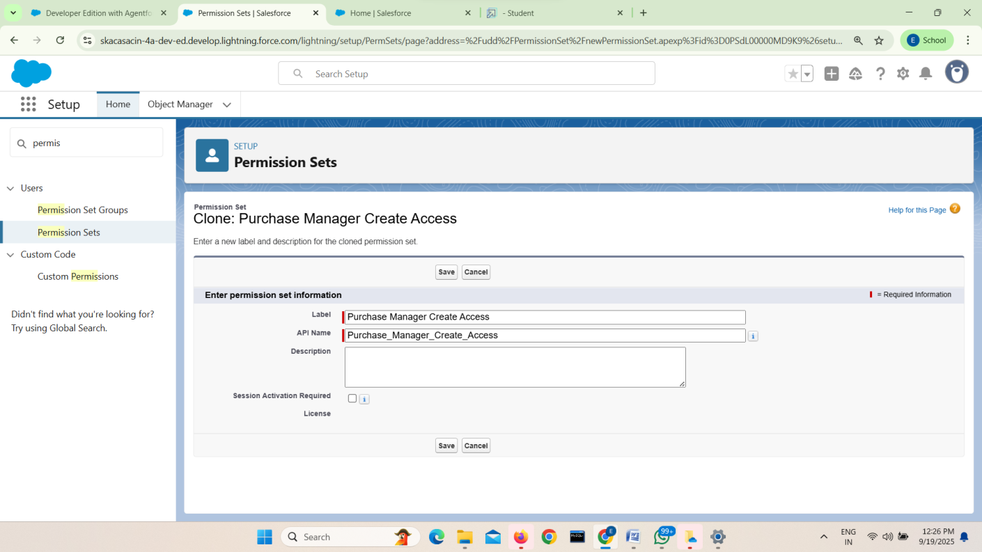

# AutomationsandWorkflows:

➔**Flows:**

Automateprocessessuchascreatingpurchaseordersorupdatingstocklevels,guidingusers through step-by-step workflows to ensure accuracy, efficiency, and reduced manual effort.

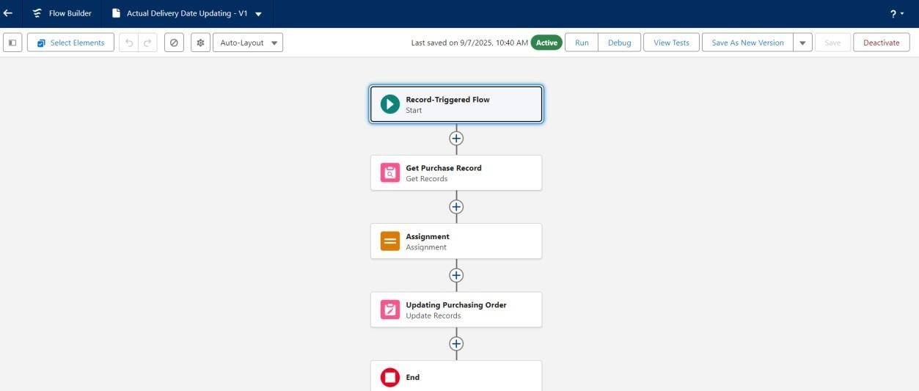

## ➔Apex Triggers:

Implement custom logic, such as automatically updating inventory quantities when order itemsarereceivedortriggeringalertsfornear-expirymedicines,tomaintainaccuracyand optimize stock management.

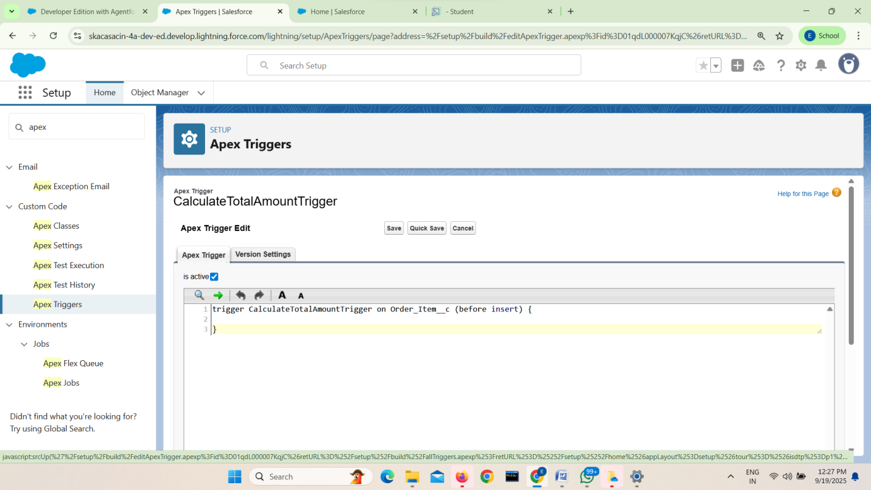

## ➔Reports:

Reportsareusedtoorganize,summarize,andanalyzedatastoredinthesystem,creating reports helps healthcare staff and administrators make data-driven decisions, track inventory performance, and maintain operational efficiency.

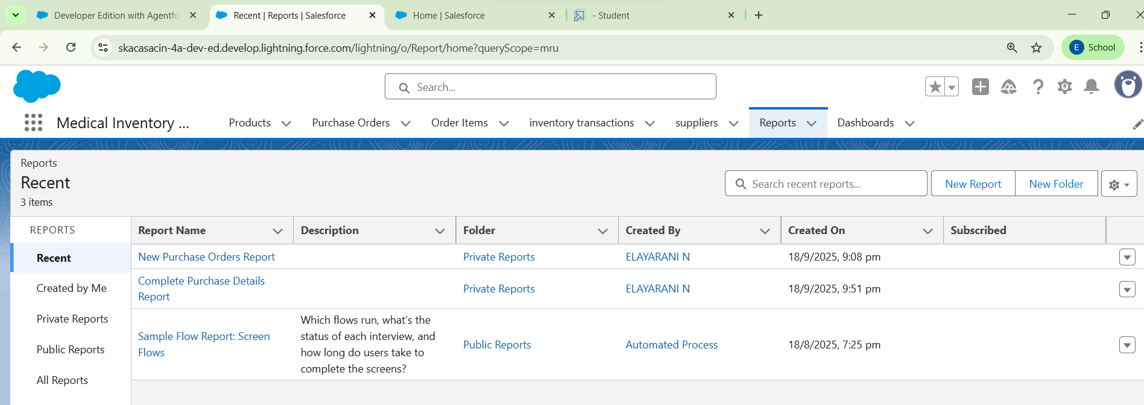

➔[**PurchaseOrdersbasedon Suppliers**](https://orgfarm-5c8bca13d9-dev-ed.develop.lightning.force.com/lightning/r/sObject/00OgL000004rHurUAE/view?queryScope=userFolders)**:**

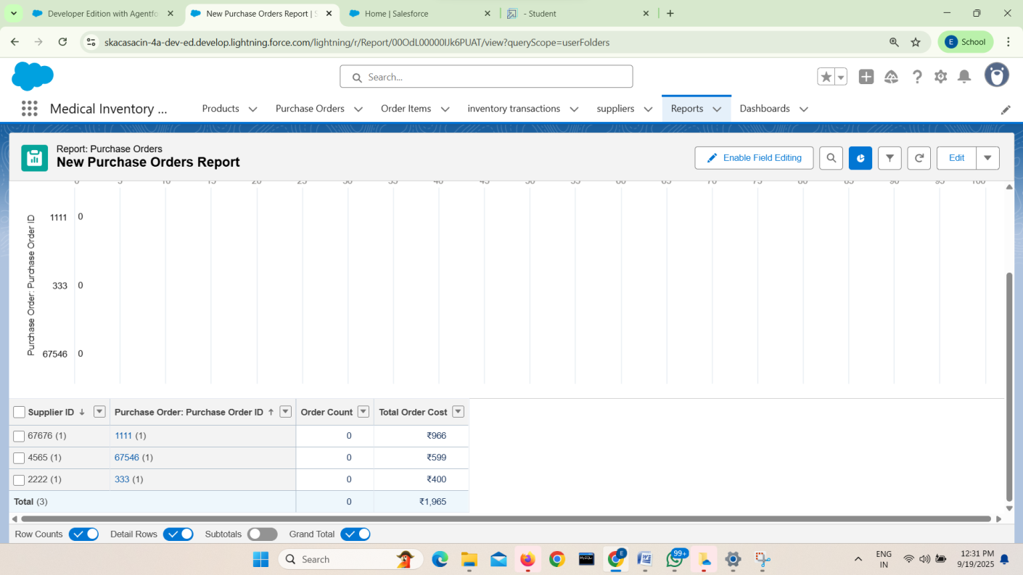

➔[**Complete PurchaseDetails Report**](https://orgfarm-5c8bca13d9-dev-ed.develop.lightning.force.com/lightning/r/sObject/00OgL000004rJ8fUAE/view?queryScope=userFolders)**:**

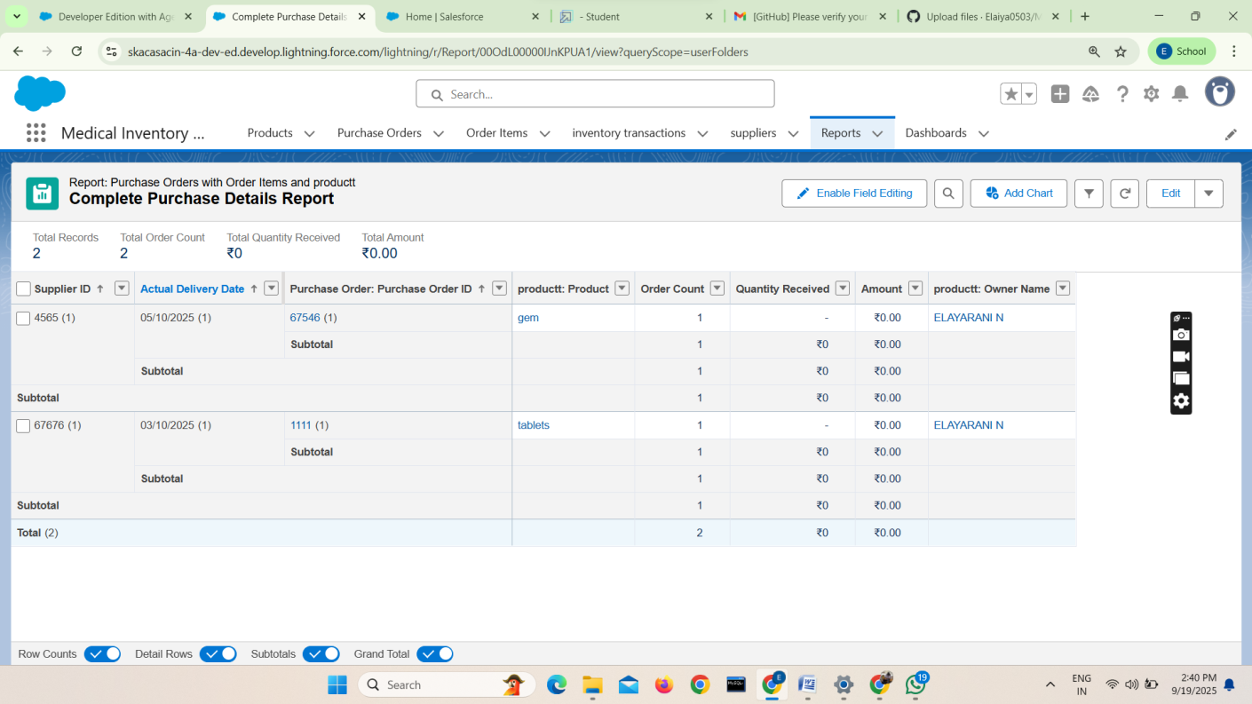

## ➔Dashboards:

Dashboards provide visual representations of key data, helping users understand trends andmakeinformeddecisionsataglance.Thedashboard(MedicalInventoryManagement) helpadministrators,pharmacists,andhealthcarestaffmonitorinventoryandprocurement efficiently.

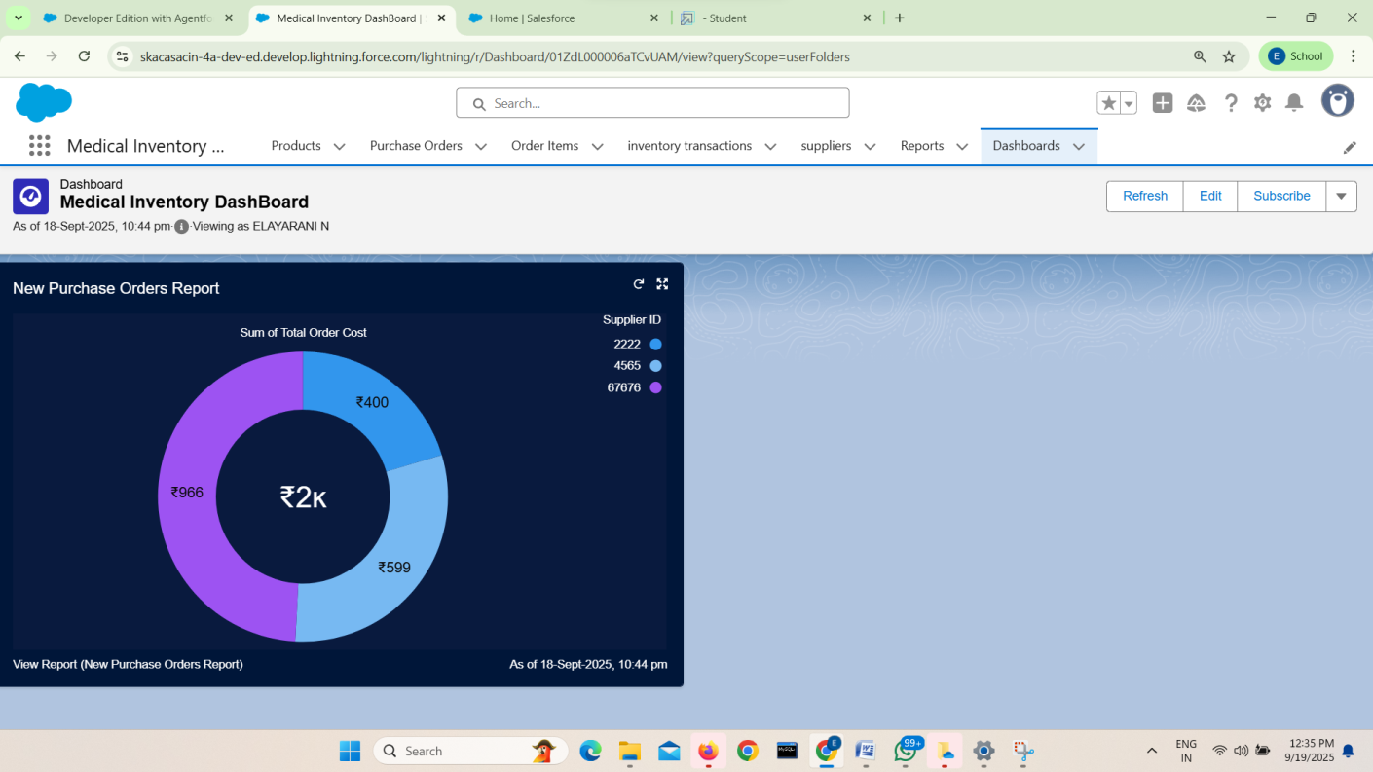

# 6.Conclusion:

The development of the Medical Inventory Dashboard has significantly enhanced the monitoring and management of purchase orders within the system.Byprovidingsupplier-basedinsightsthroughinteractivevisualizations, thedashboardsimplifiesdatainterpretationandpromotesinformeddecision- making. Real-time updates ensure accuracy, while integrated reports allow users to access detailed information seamlessly. The clear representation of order distribution across suppliers improves transparency and accountability. Additionally, the ability to refresh, edit, and subscribe to the dashboard increases its usability and adaptability. This solution not only optimizes procurement tracking but also strengthens inventory control processes.

Overall,thedashboardcontributestoimprovedefficiency,bettersupplier management, and a more effective medical supply chain.